horizontal line

**School of Life Science Capstone Design 1**

Fall Semester (2019)

Construction of a mathematical model of HIV infection in Korea

**A study on ways to contain the soaring number of HIV patients.**

Hoe-Jun Kwon (21500040)

ACADEMIC ADVISOR: Prof. Ah-Ram Kim

# INTRODUCTION

## HIV/AIDS Severity in Korea

According to UNAIDS.info the annual global AIDS outbreak from 1990 to 2018 shows an average annual decrease of 16 percent from 2000 to 2018, and compared to 1990, -9.6 percent decrease can be seen, whereas Korea has seen a growth rate of about 1802 percent as of 2018 compared to the 1990s and an average annual increase of 111 percent Also, according to the KCDC's 2018 HIV/AIDS report, there are 12,991 cumulative infections in the country by 2018, and about 1,000 new infections have been reported and received since 2013, with the risk of HIV/AIDS increasing even more sharply in South Korea while the number of infections is declining worldwide. Therefore, we seek and analyze the factors for HIV/AIDS and try to find and apply educational aspects that can inhibit these factors to design and effectively inhibit HIV/AIDS infection models.

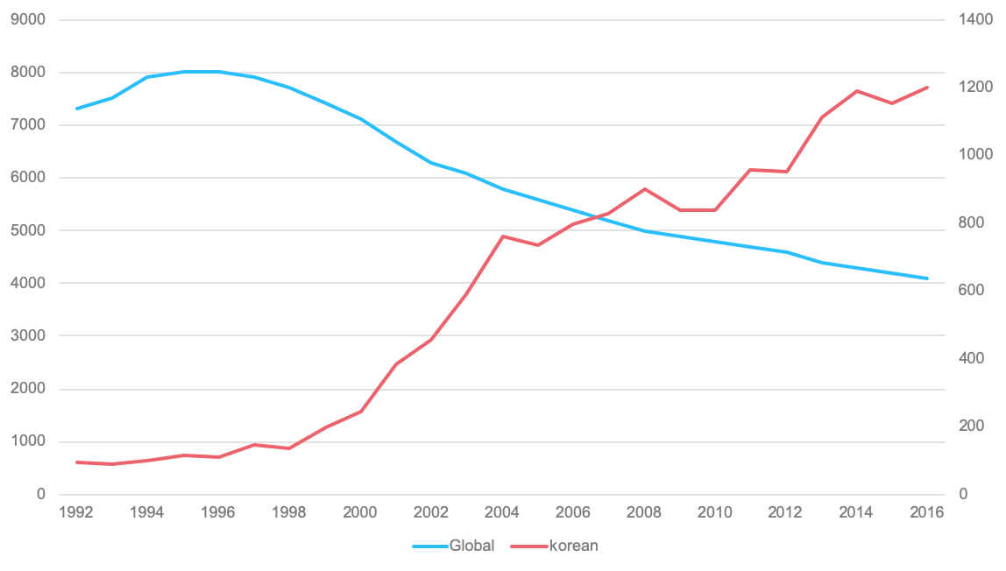

## Characteristics of HIV/AIDS in Korea

There are two main characteristics of the spread of AIDS infection in Korea. The first is that more than 90 percent of the infected are male, and the second is that the infection route is limited to sexual contact. According to a 2016 survey by the Korea Centers for Disease Control and Prevention, 54.4 percent of men were infected through heterosexual sexual contact and 45.6 percent through same-sex sexual contact. But now, socially a negative perception to prevail about homosexuality, these numbers are infected through same-sex sexual contact because the statistics that reflected the mindset and intentions.Infected, even to skewed answers to health authorities are also recognized that it is highly possible.After all, South Korea can see that Men who have sex with men (MSM) has become a major infectious group, and that HIV/AIDS continues to spread in them.

## Research Background

PrEP is a way of preventing HIV infection by using antiretroviral drugs in advance for high-risk people who are not infected with HIV, although it is not yet implemented in Korea, but is already widely used overseas.[14,15,16]. However, this method should be taken once a day, with the downside being that the preventive effect varies greatly depending on its implementation. There is also a risk of increasing dangerous sex practices and, rather, further encouraging HIV/AIDS infection by fostering awareness of safety in high-risk groups. After all, chemical precautions such as PrEP cannot be a fundamental measure of HIV/AIDS infection. Considering the fact that the nation's major infection route is MSM's sexual activity at present, it is thought that it is important to prevent dangerous sex through proper sex education rather than through chemical therapy.

Men and men anal intercourse is recognized by the Centers for Disaster Control and Prevention (CDC) in the United States as the most dangerous form of sexual intercourse that infects HIV/AIDS. However, with the human rights issue of homosexuals becoming an issue, education and reporting on the link between AIDS and homosexuality have not been carried out properly. In this study, we believe that the most effective way to prevent HIV infection is to minimize sexual contact with the infected or high-risk groups, and we will demonstrate the preventive effects of the various education below.

# RESEARCH GOALS

1. To find out how effective education is compared to prep.
2. Suggesting measures to expand education in Korean society when the effectiveness of education is proven

# 

# MILESTONES

## Acquisition and estimation of key model parameters

To find indicators that can actually affect infection, primarily as a way to see the difference between the effectiveness of education and the Prep. This includes the most commonly found values of infection rates when condoms are used, and unprotected analysis interCousre (UAIC) is more likely to be infected than when normal sex is conducted. It also considered not only in the education of physically preventable methods, but also in the mental aspects, such as the rate of infections that can occur through homosexuality due to gender identity confusion and the relative numbers of cases in which HIV can be transmitted to other people because they are not actually infected or are not diagnosed when they are suspected of being infected. In addition, the ratio of normal males to MSM and the rate of HIV transmission, which is spread according to males and females, are separately measured through simulation because they do not conform to the Korean model to be introduced based on actual papers. For Prep, refer to CDC.

## Construction of a mathematical model of HIV infection in Korea

Select and refer to several papers based on theses predicting a specific disease through differential equations, and construct the Ordinal Differential Equation based on the SIR model, a common infectious disease diffusion model. Each parameter is introduced into the equation to measure the variation in infectious magnetism according to parameters, mainly because it is a method for viewing changes according to parameter effects. At this time, the algorithm for infectious propagation is configured in advance, and the parameters are set according to the direction of the algorithm and the equation is constructed.

## *In silico* simulation of HIV infection

Simulate how similar the actual data was to be estimated through the first constructed equation. After measuring whether the differential equation can be predicted well through actual simulation, if there is an error based on the measurement, find the part to be modified in the differential equation or change the value for the parameter to optimize the equation similarly to the actual data. Estimate the number of infections based on four scenarios with optimized equations. Each scenario is constructed in the following directions: 1. both education and prep. 2. education only. 3. Only Prep 4. both education and Prep.

## 

## 

## Comprehensive analysis of model results

Measure the number of infections through four pre-set scenarios. Based on the measured number of infections, compare scenario 1 and the remaining scenarios to show the seriousness of the actual introduction (Scenario 1) and refer to the importance of each parameter and measure the effects of each parameter in the remaining scenarios to schematize the differences by parameter. Based on the schematic parameters, the importance of each parameter can be checked according to the infectious group.

## Getting novel insights and better solutions from the results

Cost-wise analysis of the effects on Prep and the rest of the training can be made to further compare the effects on the economic side. If the effectiveness of education relative to the PreP is reasonable for the amount, a policy approach can be taken to support the nation's preventive education. In addition, the fact that the number of infected people in the undiagnosed infection group is much higher than those actually managed by the country suggests effective management of the country based on parameters.

# RESULTS

## Construction of a mathematical model

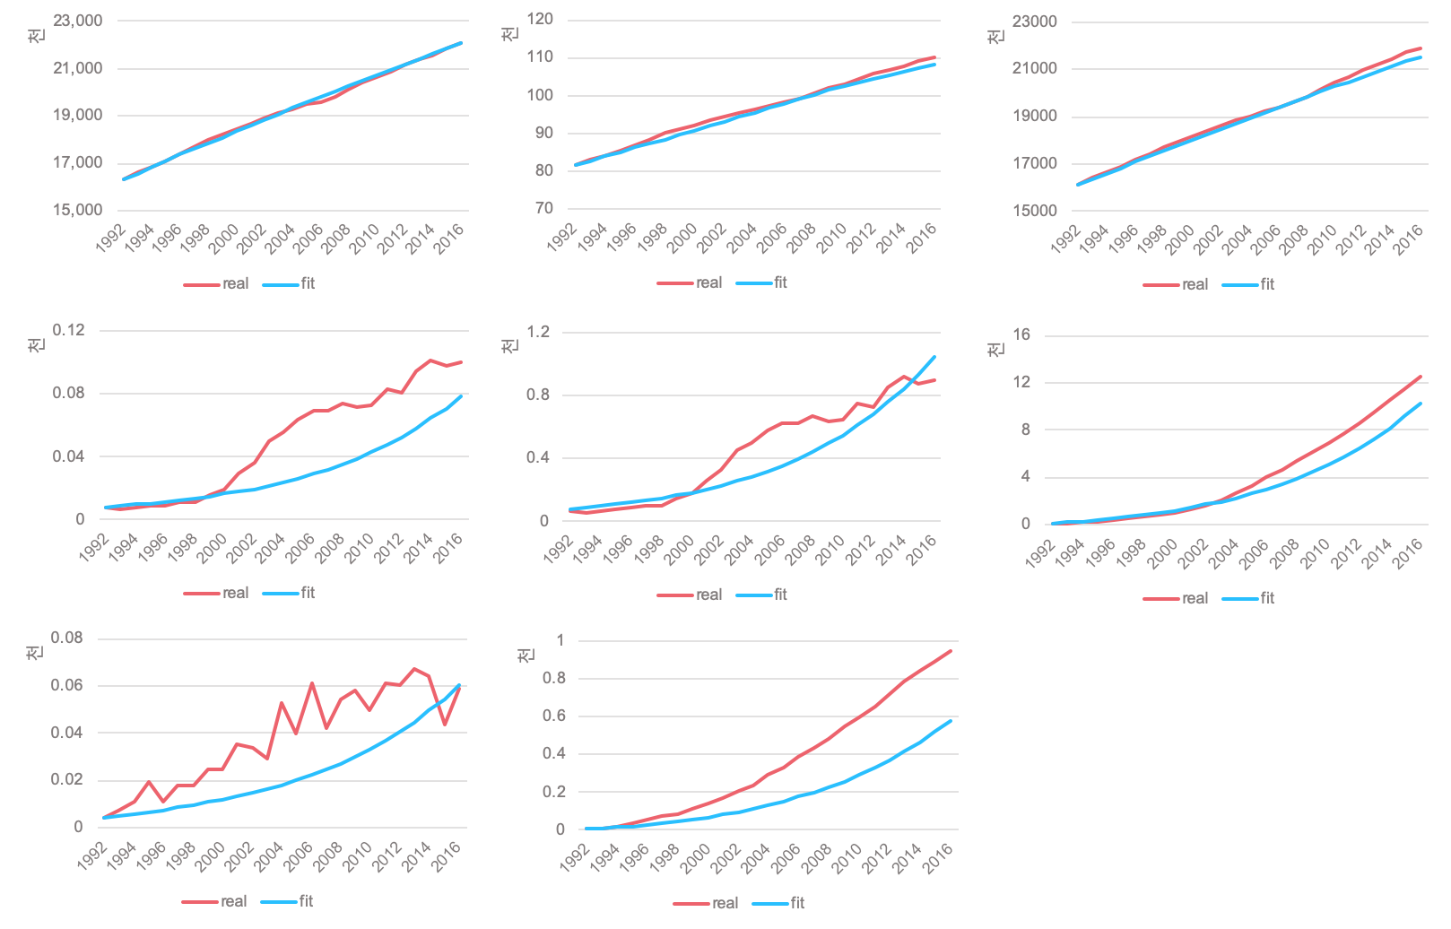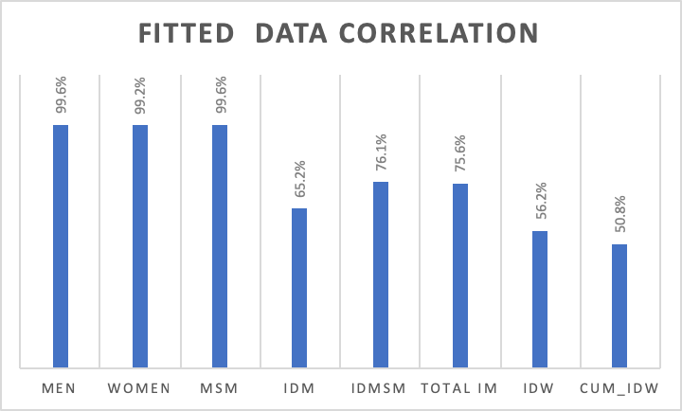



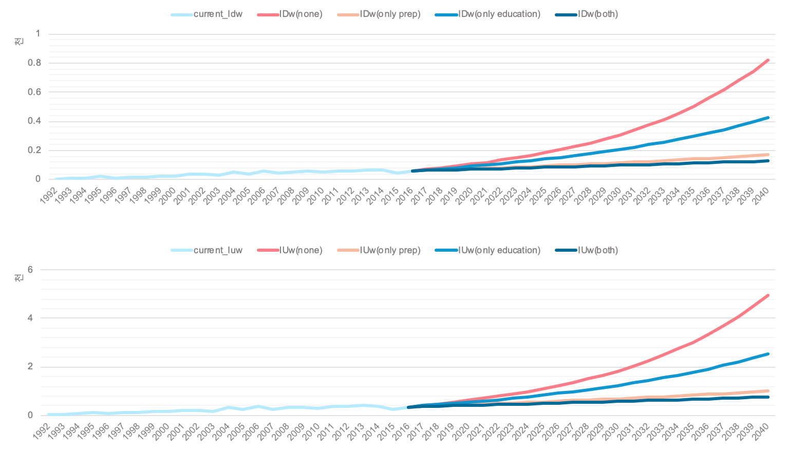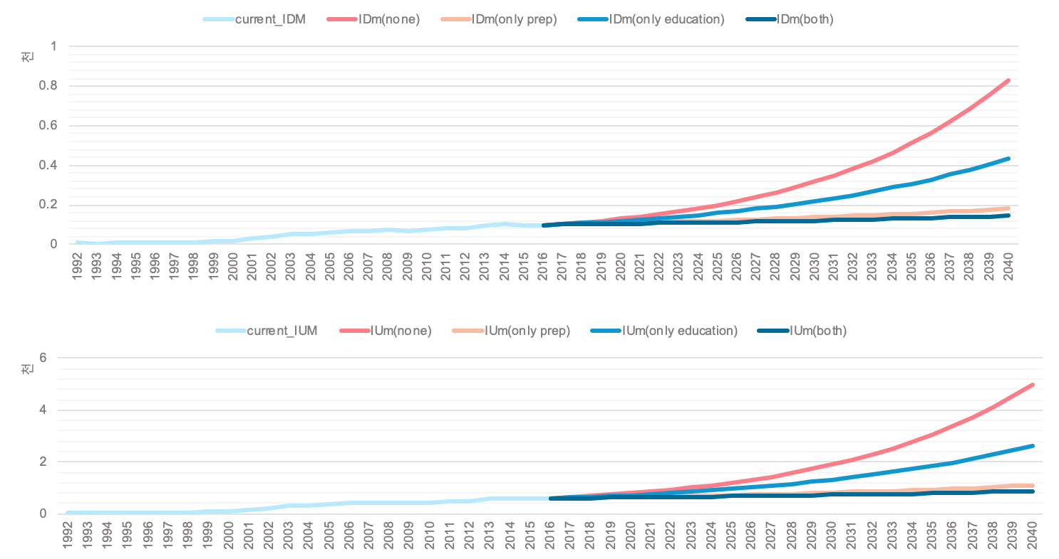

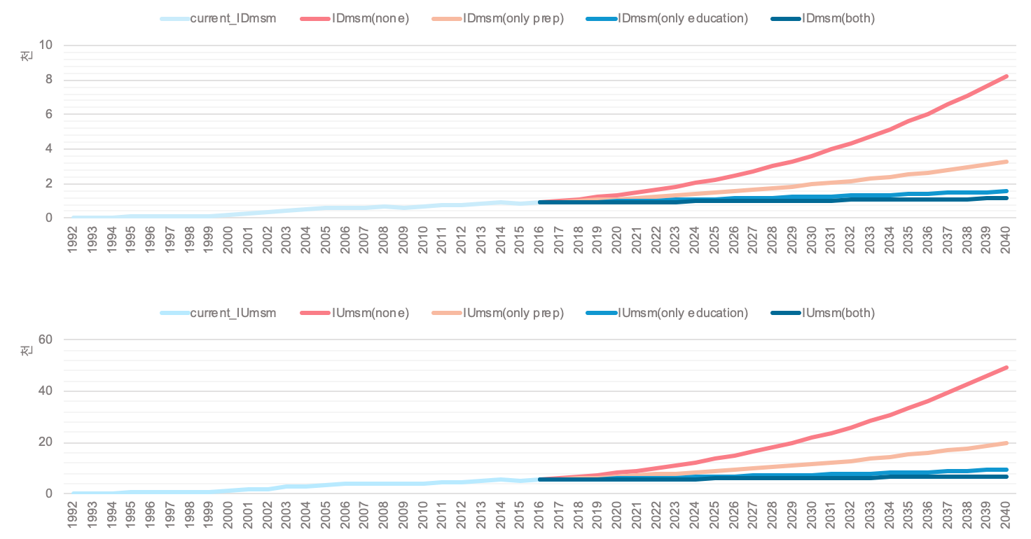



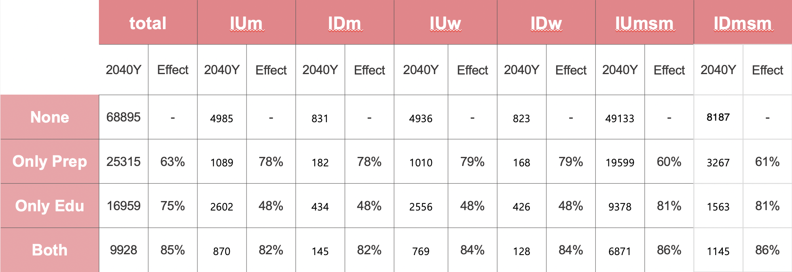



# CONCLUSION

Errors can exist in measuring the actual number of infections because they are not fully optimized models. However, we believe that the algorithm is not negligible in predicting patients in the future, and that it is significant in that it can identify factors that may affect the value of the parameters contained in the algorithm and find appropriate precautions. In this study, the effectiveness of education is hard to ignore, even though the comparison does not make any economic sense of prep and education, and the majority of HIV-infected groups are MSMs, although the effects of education are not considered significant. Therefore, if the model's optimization increases accuracy and economic models are constructed based on the results, it will provide a valid basis for supporting the importance of education, which in turn will lead to policy suggestions.

# MATERIALS & METHODS

## Modeling algorithms

Considering that most of the HIV infections in Korea are transmitted through sex, we divided the population over 15 into seven groups: YM(men who have sex with women), YW(women who have sex with men), MSM(men who have sex with men),IDm(among men who have sex with women was diagnosed with HIV),IUm(among men who have sex with women was undiagnosed with HIV),IDw(among women who have sex with men was diagnosed with HIV),IUw(among women who have sex with men was undiagnosed with HIV),IDmsm(among men who have sex with men was diagnosed with HIV),IUmsm(among men who have sex with men was undiagnosed with HIV), Figure 4 is a complete diagram of the model and Table 2 shows the meaning of system variables.

## 

| Variable | Meaning | | Reference |
| --- | --- | --- | --- |
| D | Annual cumulative death | | [1] |
| YM | General men over 15 years of age per year with non-infected | | [1] |
| YW | General women over 15 years of age per year with non-infected | | [1] |
| Ymsm | MSM over 15 years of age per year with non-infected | | Calculated |
| IDM | among men who have sex with women was diagnosed with HIV per year | | [2] |
| IDW | among women who have sex with men was diagnosed with HIV per year | | [2] |
| IDmsm | among men who have sex with men was diagnosed with HIV per year | | Calculated |
| IUM | among women who have sex with men was undiagnosed with HIV per year with infected | | [2],estimated |
| IUW | among women who have sex with men was undiagnosed with HIV per year with infected | | [2],estimated |
| IUmsm | among women who have sex with men was undiagnosed with HIV per year with infected | | [2],estimated |
| *Ymsm= YM · 0.005, *IDmsm= IDM · 0.9 | | | |



| Parameter | Meaning | | Value | Unit | Reference |
| --- | --- | --- | --- | --- | --- |
| M | Annual YM inflow population | | - |  | [1] |
| W | Annual YW inflow population | | - |  | [1] |
|  | Condom usage Education | | 20 | % | [3],[4].[5] |
|  | UAIC prevention Education | | 50 | % | [6] |
|  | Sexual identity establishment education | | 26.5 | % | [7] |
|  | AIDS Recognition and Diagnosis Education | | 10 | % | [8] |
| p1 | Prep preventive effect in UAIC | | 44 | % | [9] |
| p2 | Prep prevention effect in heterosexual sex | | 62.2 | % | [10] |
| **𝜶** | Percentage of annual YM to msm | | - | % | estimated |
| 𝜷 | Rate of infection when having sex with HIV patients(men to women) | | - | % | estimated |
| 𝜸 | Rate of infection when having ssdex with HIV patients(women to men) | | - | % | estimated |
| ε | Rate of infection when having sex with HIV patients(men to men) | | - | % | estimated |
| V | Diagnosis rate | | 16.67 | % | [11] |
| *d(m,w)* | Death rate for men & women | | - | % | Calculated,[1] |
| *UAIC : Unprotected Anal Intercourse  *PrEP: Pre-exposure prophylaxis | | | | | |



## Hypothesis

| 1) Both HIV/AIDS infections in South Korea are infected through sexual intercourse between the uninfected and the infected.  2) Ignore the effects of HIV-related education prior to 2016.  3) Infection through bisexuality is ignored. |
| --- |

## Model Formulation

the rate of infection through heterosexual sex β,𝜸 and homosexual sex was shown as ε. Since the number of infections in each group is proportional to the proportion of the infected group in the group having sex, the annual number of infections in the group Ym, Yw and Ymsm may be expressed as expressions (1), (2), and (3) of Figure 3 below.

|  |
| --- |



Adding a parameter to the expression in Figure 5 that indicates the effect of education and PrEP is represented by the expressions (4), (5), and (6) of Figure 6 below. The meaning of each parameter in the expression can be found in Table3.

|  |
| --- |



α is the rate at which men who have sex with men each year have sex with men. The expression (7) of Figure 7 refers to the number of men flowing from Ym to msm.

|  |
| --- |



M and W refer to the number of people flowing into men or women aged 15 or older each year, and d refers to mortality. The change in group over time of the entire model can be found in Figure 8.

|  |
| --- |

## 

## Exploratory Data Analysis

Each year, men and women numbers over the age of 15 used data provided by KOSIS. In addition, the number of HIV infections in men and women each year used data from the "2018 HIV report status" provided by the Korea Centers for Disease Control and Prevention.Each year, the number of Ymsm was set at 0.05 percent for 15-year-olds.[12] The number of IDmsm each year was set at 90% of the total men infections.[13] D values were also set based on data from KOSIS. Estimate the values of α, β, γ and ε using the expressions of Figure 8 based on the population of the group from 1992 to 2016.

| Parameter | | Estimated Value |
| --- | --- | --- |
| 𝜶 | | 1.183e-04 |
| 𝜷 | | 0.104 |
| 𝜸 | | 0.035 |
| ε | | 0.119 |



e1; implementation when training related to condom use was obtained by multiplying the effectiveness of HIV infection when actually using condoms.

e2; no direct data was found on the effect of education on the prevention of anal intercourse. However, the e2 values were inferred by referring to the data on the extent to which the applicable hazard actions were committed when training related to priorities, sex initialization, unprotected sex, frequency of sex, etc.

e3; Sexual identity education is an education that does not have confidence in one's sexuality due to an acquired environment, so that one can have the right sexual identity in the case of inevitably going in the direction of homosexuality and thus prevent damage caused by MSM.

e4; We estimated comprehensively and inferred from cases where carriers are diagnosed with actual domestic HIV infections because of their perception of HIV infection and whether or not they are aware of the risk of HIV because of differences in sex.

## Step-by-step method of running the software

### **All the programs were written in Excel and R.**

**First, create an environment where functions can be implemented through the installation of libraries.**



| library(deSolve) library(gridExtra) library(ggplot2) |
| --- |

desolve : Packages that enable differentiation

gridExtra: In ggplot, it serves as par(mfrow = c (,)) for the R base package.

ggplot2: It draws the graph delicately and beautifully.

**Second, it constitutes a function. The component is the location where the parameter, time and location for variables. Equation was formed based on figure 8.**

| HIV <- function(time, state_values, parameters) {    Ym = state_values [1] # over 15 years-old men  Yw = state_values [2] # over 15 years-old women  Ymsm = state_values [3] # over 15 years-old MSM  IUm = state_values [4] # over 15 years-old infected men  IDm = state_values [5]   IUw = state_values [6] # over 15 years-old infected women  IDw = state_values [7]   IUmsm = state_values [8] # over 15 years-old MSM  IDmsm = state_values [9]  D = state_values [7] # Death    with(as.list(c(state_values, parameters)), {    dYm<-M-(1-e2)*alpha*Ym-(1-p2)*(1-e1)*(1-e4)*beta*(((V+1)*IUw)/((V+1)*IUw+Yw))*Ym-d_m*Ym    dYw<- W-(1-p2)*(1-e1)*(1-e4)*gamma*(((V+1)*IUm)/((V+1)*IUm+Ym))*Yw-d_w*Ym    dYmsm<-(1-e2)*alpha*Ym-(1-p1)*(1-e1)*(1-e3)*(1-e4)*epsillon*(((V+1)*IUmsm)/((V+1)*IUmsm+Ymsm))*Ymsm-d_m*Ymsm    dIUm<-(1-p2)*(1-e1)*(1-e4)*beta*(IUw/((V+1)*IUw+Yw))*Ym-d_m*IUm    dIDm<-(1-p2)*(1-e1)*(1-e4)*beta*((V*IUw)/((V+1)*IUw+Yw))*Ym-d_m*V*IUm     dIUw<-(1-p2)*(1-e1)*(1-e4)*gamma*(IUm/((V+1)*IUm+Ym))*Yw-d_w*IUw     dIDw<-(1-p2)*(1-e1)*(1-e4)*gamma*((V*IUm)/((V+1)*IUm+Yw))*Yw-d_w*V*IUw     dIUmsm<-(1-p1)*(1-e1)*(1-e3)*(1-e4)*epsillon*(IUmsm/((V+1)*IUmsm+Ymsm))*Ymsm-d_m*IUmsm     dIDmsm<-(1-p1)*(1-e1)*(1-e3)*(1-e4)*epsillon*((V*IUmsm)/((V+1)*IUmsm+Ymsm))*Ymsm-d_m*V*IUmsm     dD <- d_m*Ym+d_w*Yw+d_m*Ymsm+d_m*IUm+d_m*V*IUm+d_w*IUw +d_w*V*IUw+d_m*IUmsm+d_m*V*IUmsm    return(list(c(dYm, dYw, dYmsm, dIUm, dIDm, dIUw, dIDw, dIUmsm, dIDmsm, dD)))  }) } |
| --- |
|  |

**Third, optimize parameters. The criteria are based on RMSE values and the four main target parameters are determined through iteration to be the lowest of the four values.**

| seed(1234)  data<-c() for (i in 1:10000){  for (j in 1:1000){  for (k in 1:1000){  for (l in 1:1000){  parameters <- c(alpha= 1.000e-04+(0.0000001*i), beta = 0.05+(0.0001*j), gamma = 0.014+(0.001*k), epsillon=0.1+(0.001*l), e1=0,e2=0,e3=0,e4=0,p1=0,p2=0,d_m=0.006868651,d_w=0.005817024,M=223322+151489,W=210682+127508,V=0.1667)  ou1 <- as.data.frame(ode(init, seq(1992, 2016, by = 1), HIV, parameters))  fit_Ymsm<-ou1[4]  msm<-as.data.frame(pop$men*0.005)  fit_Ymsm<-as.data.frame(fit_Ymsm)  error<-rmse(pop$men*0.005,unlist(fit_Ymsm[,1]))  data[i]<-error  }}}}  min(data) which(data== 671.8952,arr.ind = FALSE) head(data,10000) |
| --- |
|  |

# Fourth, set the optimization parameters. If M and W, d_m, d_w, d_w, etc. are established through data from KOSIS.

| parameters <- c(alpha= 1.183e-04, beta = 0.104, gamma = 0.035, epsillon=0.119, e1=0,e2=0,e3=0,e4=0,p1=0,p2=0,d_m=0.006868651,d_w=0.005817024,M=223322+151489,W=210682+127508,V=0.1667) |
| --- |

# 

# 

# 

# 

# 

# Fifth. sets the initial value. The initial value is the value at which the prediction will begin, when the data for the initial value is from 1992.

| init<- c(Ym = pop$men[1], Yw=pop$women[1], Ymsm = pop$men[1]*0.005, Im = pop$in_men[1]*0.1,Iw = pop$in_women[1], Imsm =pop$in_men[1]*0.9) |
| --- |

# 

# Sixth, the ode function uses a desolve library to indicate a differential value. The seq is the period and indicates the interval to be predicted.

| ou1 <- as.data.frame(ode(init, seq(1992, 2016, by = 1), HIV, parameters)) |
| --- |

**Seventh. identifies the differential value. The values obtained can be used to represent a graph, either by creating a graph on the R itself or by using only the data as an Excel graph.**

| fit_Ym<-ou1[2] fit_Yw<-ou1[3] fit_Ymsm<-ou1[4] fit_IUm<-ou1[5] fit_IDm<-ou1[6] fit_IUw<-ou1[7] fit_IDw<-ou1[8] fit_IUmsm<-ou1[9] fit_IDmsm<-ou1[10] |
| --- |

# Eighth, if you proceed with R, first convert the data to a data frame for 1992, which will be the reference.

| y<-as.data.frame(pop$year) m<-as.data.frame(pop$men) w<-as.data.frame(pop$women) msm<-as.data.frame(pop$men*0.005) IUm<-as.data.frame(pop$in_men*0.1*(1/V)) IDm<-as.data.frame(pop$in_men*0.1) IUw<-as.data.frame(pop$in_women*(1/V)) IDw<-as.data.frame(pop$in_women) IUmsm<-as.data.frame(pop$in_men*0.9*(1/V)) IDmsm<-as.data.frame(pop$in_men*0.9) |
| --- |

**Ninth. to make each data value into a data frame, and then add another factor to distinguish each group.**

| **fit_Ym<-as.data.frame(fit_Ym) fit_Yw<-as.data.frame(fit_Yw) fit_Ymsm<-as.data.frame(fit_Ymsm) fit_IUm<-as.data.frame(fit_IUm) fit_IDm<-as.data.frame(fit_IDm) fit_IUw<-as.data.frame(fit_IUw) fit_IDw<-as.data.frame(fit_IDw) fit_IUmsm<-as.data.frame(fit_IUmsm) fit_IDmsm<-as.data.frame(fit_IDmsm)   ## fit.m<-cbind(y,fit_Ym) fit.w<-cbind(y,fit_Yw) fit.msm<-cbind(y,fit_Ymsm) fit.IUm<-cbind(y,fit_IUm) fit.IDm<-cbind(y,fit_IDm) fit.IUw<-cbind(y,fit_IUw) fit.IDw<-cbind(fit_IDw) fit.IUmsm<-cbind(y,fit_IUmsm) fit.IDmsm<-cbind(y,fit_IDmsm)  ## real.m<-cbind(y,m) real.w<-cbind(y,w) real.msm<-cbind(y,msm) real.IUm<-cbind(y,IUm) real.IDm<-cbind(y,IDm) real.IUw<-cbind(y,IUw) real.IDw<-cbind(y,IDw) real.IUmsm<-cbind(y,IUmsm) real.IDmsm<-cbind(y,IDmsm) ## real.m$group<-c("real") real.w$group<-c("real") real.msm$group<-c("real") real.IUm$group<-c("real") real.IDm$group<-c("real") real.IUw$group<-c("real") real.IDw$group<-c("real") real.IUmsm$group<-c("real") real.IDmsm$group<-c("real") ## fit.m$group<-c("fit") fit.w$group<-c("fit") fit.msm$group<-c("fit") fit.IUm$group<-c("fit") fit.IDm$group<-c("fit") fit.IUw$group<-c("fit") fit.IDw$group<-c("fit") fit.IUmsm$group<-c("fit") fit.IDmsm$group<-c("fit") ## names(real.m)[1:2]<-c("year","men") names(fit.m)[1:2]<-c("year","men")  names(real.w)[1:2]<-c("year","women") names(fit.w)[1:2]<-c("year","women")  names(real.msm)[1:2]<-c("year","msm") names(fit.msm)[1:2]<-c("year","msm")  names(real.IUm)[1:2]<-c("year","IUm") names(fit.IUm)[1:2]<-c("year","IUm")  names(real.IDm)[1:2]<-c("year","IDm") names(fit.IDm)[1:2]<-c("year","IDm")  names(real.IUw)[1:2]<-c("year","IUw") names(fit.IUw)[1:2]<-c("year","IUw")  names(real.IDw)[1:2]<-c("year","IDw") names(fit.IDw)[1:2]<-c("year","IDw")  names(real.IUmsm)[1:2]<-c("year","IUmsm") names(fit.IUmsm)[1:2]<-c("year","IUmsm")  names(real.IDmsm)[1:2]<-c("year","IDmsm") names(fit.IDmsm)[1:2]<-c("year","IUmsm")  ## data.m<-rbind(real.m,fit.m) data.w<-rbind(real.w,fit.w) data.msm<-rbind(real.msm,fit.msm)  data.IUm<-rbind(real.IUm,fit.IUm) data.IDm<-rbind(real.IDm,fit.IDm) data.IUw<-rbind(real.IUw,fit.IUw) data.IDw<-rbind(real.IDw,fit.IDw) data.IUmsm<-rbind(real.IUmsm,fit.IUmsm) data.IDmsm<-rbind(real.IDmsm,fit.IDmsm)** |
| --- |

**Tenth. produces a graph from the data frame that is created. Use ggplot 2 at this time.**

| **## pred_y<-seq(1992, 2016, by = 1) pred_m<-cbind(pred_y,fit_Ym) names(pred_m)<-c("year","men") ggplot(data=pred_m, aes(x=year, y=men))+geom_point()+geom_line()+theme(legend.position = c(0.8, 0.1),legend.direction = "horizontal") ## pred_w<-cbind(pred_y,fit_Yw) names(pred_w)<-c("year","women") ggplot(data=pred_w, aes(x=year, y=women))+geom_point()+geom_line()+theme(legend.position = c(0.8, 0.1),legend.direction = "horizontal") ## pred_msm<-cbind(pred_y,fit_Ymsm) names(pred_msm)<-c("year","msm") ggplot(data=pred_msm, aes(x=year, y=msm))+geom_point()+geom_line()+theme(legend.position = c(0.8, 0.1),legend.direction = "horizontal") ## pred_IDmsm<-cbind(pred_y,fit_IDmsm) names(pred_IDmsm)<-c("year","IDmsm") ggplot(data=pred_IDmsm, aes(x=year, y=IDmsm))+geom_point()+geom_line()+theme(legend.position = c(0.8, 0.1),legend.direction = "horizontal") ## pred_IUmsm<-cbind(pred_y,fit_IUmsm) names(pred_IUmsm)<-c("year","IUmsm") ggplot(data=pred_IUmsm, aes(x=year, y=IUmsm))+geom_point()+geom_line()+theme(legend.position = c(0.8, 0.1),legend.direction = "horizontal") ## pred_IUmsm<-cbind(pred_y,fit_IUmsm) names(pred_IUmsm)<-c("year","IUmsm") ggplot(data=pred_IUmsm, aes(x=year, y=IUmsm))+geom_point()+geom_line()+theme(legend.position = c(0.8, 0.1),legend.direction = "horizontal") ## pred_IUm<-cbind(pred_y,fit_IUm) names(pred_IUm)<-c("year","IUm") ggplot(data=pred_IUm, aes(x=year, y=IUm))+geom_point()+geom_line()+theme(legend.position = c(0.8, 0.1),legend.direction = "horizontal") ## pred_IDm<-cbind(pred_y,fit_IDm) names(pred_IDm)<-c("year","IDm") ggplot(data=pred_IDm, aes(x=year, y=IDm))+geom_point()+geom_line()+theme(legend.position = c(0.8, 0.1),legend.direction = "horizontal")** |
| --- |

**Predictive value for the actual value through such code numbers add up correlation can do this they are fitting and can be found. Currently, this shows only fitting values, not actually predicting them until 2040, but only increasing the seq () value to 2040 results in relevant values.**

# 

# REFERENCES

[1] 국가통계 포털 KOSIS(KOrean Statistical Information service)

[2] 질병관리본부 (2019). *2018 HIV/AIDS 신고현황*

[3] DiClemente, R., Wingood, G., Harrington, K., Lang, D., Davies, S., Hook III, E., Oh, M., Crosby, R., Hertzberg, V., Gordon, A., Hardin, J., Parker, S. and Robillard, A. (2004). Efficacy of an HIV Prevention Intervention for African American Adolescent Girls. *JAMA*, 292(2), p.171.

[4] Go Uy Kee MK Choi BS Kang C, Do KM, Lee JS. Male to female Heterosexual transmission of HIV in Korea: Transmission rate and risk factors. Korean J Prev Med 1999; 32(2):

[5] Martine JL, Dean L, Garcia M, Hall W. Barbara Snell Dohrenwend memorial lecture. The impact of AIDS on a gay community : changes in sexual behavior, substance use, and mental health. *Am J Community Psychol* 1989 Jun; 17(3): 269-293

[6] Kirby, D., Laris, B. and Rolleri, L. (2007). Sex and HIV Education Programs: Their Impact on Sexual Behaviors of Young People Throughout the World. *Journal of Adolescent Health*, 40(3), pp.206-217.

[7] Rankin, S., Blumenfeld, W. J., Weber, G. N., & Frazer, S. (2010). State of higher education for LGBT people. *Charlotte, NC: Campus Pride*.

[8] 질병관리본부(2015). 에이즈에 대한 지식, 태도, 신념 및 행태 조사

[9] Robert M. GrantStudy TeamiPrEx. (2010). Preexposure chemoprophylaxis for HIV prevention in men who have sex with men. New England Journal Med.

[10] Thigpen, M. C., Kebaabetswe, P. M., Paxton, L. A., Smith, D. K., Rose, C. E., Segolodi, T. M., ... & Mutanhaurwa, R. (2012). Antiretroviral preexposure prophylaxis for heterosexual HIV transmission in Botswana. *N Engl j Med*, *2012*(367), 423-434.

[11] Kim SB, Yoon M, Ku NS, Kim MH, Song JE, Ahn JY, et al. (2014) Mathematical Modeling of HIV Prevention Measures Including Pre-Exposure Prophylaxis on HIV Incidence in South Korea. PLoS ONE 9(3): e90080. https://doi.org/10.1371/journal.pone.0090080

[12] 한국에이즈연맹 (1996). 9월 보고서

[13] 길원평(2015). 제1차 에이즈 예방 정책포럼 - 국내 청소년 및 청년 에이즈 감염 급증 사태에 대한 원인 분석 및 정책 제안

[14] "Norway becomes first country to offer free PrEP - Star Observer". *starobserver.com.au*. Retrieved 12 January 2017.

[15] "Pre-Exposure Prophylaxis (PrEP)". *AFAO.org.au*. Australian Federation of AIDS Organizations. Retrieved 15 December 2017

[16] "Canada and Israel OK Truvada as PrEP to Prevent HIV". *POZ*. 1 March 2016. Retrieved 12 January 2017.